|  |  |  |
| --- | --- | --- |
| INDIAN INSTITUTE OF SCIENCE  BANGALORE 560 012 | **Intellectual Property Cell**  **SOCIETY FOR INNOVATION AND DEVELOPMENT (S.I.D)**  **Innovation Centre, Indian Institute of Science Campus Bangalore – 560 012.**  **TEL: (91)-(80)-2293 2037/2038/2544/2982/2983/2984, Fax: (91)-(80)-23464088,23314314**  **Email :** [**chairip@admin.iisc.ernet.in**](mailto:chairip@admin.iisc.ernet.in) | **SOCIETY FOR INNOVATION AND DEVELOPMENT**  **INNOVATION CENTRE** |

# Invention Disclosure Questionnaire

1. **Title of the Invention**

Myo-Mechanical Control Band

1. **Abstract of the Invention**

The device is a band, integral of a conductive stretch sensor and pads, that sends control signals based on the flexion and extension of fingers of the wearer continuously. The resistance of the conductive stretch sensor of the device changes with the change in its tensile strain. This property of the sensor is made use in the measurement of the circumferential change in the forearm of the wearer while in extension or flexion of the fingers. The data is manipulated through an algorithm to detect the extent of extension and flexion in the fingers. The device is simple to construct, inexpensive, easy to assemble and requires minimum startup calibration. The band is further improvised by taking into account two channels from two sensors reacting to the same change to reduce the error. A prototype also has been built to control a simple prosthetic hand to mimic the actual flexion and extension of the fingers of the wearer to demonstrate one of the uses of this device. The device can also be used to detect dorsiflexion and plantar flexion of the foot, pronation and supination of the wrist, flexion and extension of the wrist and the force of squeeze of the hand non-invasively.

1. **Key Words:**

**Control band, Myo-mechanical, Stretch sensor, Circumferential change, Global Variable change, Gesture recognition, Flexion and extension, Pads .**

1. **Area of Technology:**

The present disclosure relates generally to muscle interface devices. More specifically to the use of it in the control of prosthesis and for basic control of Machines.

1. **Background of the Invention:**

**What are the present technologies that exist in the field of your invention and what are the limitations of the same?(Present state of Art)**

1. The present technologies are Myoelectric devices which use electromyography (EMG) sensors to detect the gestures made by fingers. These are used by commercial prosthetic hands such as Bebionic, iLimb etc. These sensors give false signaling when there is sweat under the band which is considered as a limitation.
2. The control of the prosthesis through these devices in the commercially available prosthetic hands is non-intuitive. For example, flexion of the fingers in prosthetic hand requires flexion of wrist of the actual hand. This necessitates the wearer to undergo initial training.
3. Existing devices use expensive sensors (EMGs and VMGs) therefore; their cost is significantly higher.
4. Some of the devices use sEMGs which require a special gel to be applied for the detection of the gestures.
5. Force Sensitive Resistors (FSR) are used in some devices, but generally they are considered to be not so reliable.
6. Image processing technology is limited to well-lit conditions.

Since recent times the human machine interaction has been increasing. Moreover, the control of the machines has become more intuitive. The use of sensors to detect the human movements directly, has helped in improving interaction with machines. This device simplifies the human machine interaction in a different approach. The present day technologies detect the finger’s movement by various local measurement techniques viz; by detecting the sound due to movement of the muscles (AMG and PMG) , picking the electric signals from brain activity (EMG) and Vibrations caused by the movement of the muscles (VMG).Though the devices like Myo-band detect all gestures of fingers, they are expensive and cannot be put into use for low cost devices that can make use of the band. Also the technologies used by the commercial prosthetic hands use non intuitive means to control the artificial hand. Thus the need of a device which can capture the basic gestures made by hand, control the controlee through intuitive means (in this case a prosthetic hand).Also is the need for the simpler construction, light, affordable and aesthetically pleasing design.

1. **What problems does the invention address and how your Invention is able to overcome the limitations/ problems of the existing technologies?**
2. The sweat or dust underneath the device and the skin of the wearer has no effect on the sensing capabilities, as the sensor is itself not in contact with the skin.
3. In the prototype built the device controls a prosthetic hand intuitively. As the algorithm drives the motor of the prosthetic hand according to the most relevant gesture made by the hand. Not only is the position of the fingers, also force of the grasp is recognized.
4. The device uses a conductive rubber chord as a sensor which is inexpensive and also can be homemade.
5. There is no requirement of prior preparation of the skin. In fact the sensor itself doesn’t come in contact with the skin.
6. Unlike the FSR based devices, this device is reliable without a scope for false signaling.
7. FSR based devices need accurate positioning of the band such that the local measurements are taken accurately to relate it to the finger movements. This device as it involves the global measurement of the variable change, doesn’t require a specific orientation of the device.
8. Microsoft Kinnect and camera based gesture recognition devices use image processing technology to detect the gestures. Though these are fairly accurate, there is a limitation of well-lit conditions for the camera to recognize. In this device since the measurement directly comes from the muscle movement the need for well-lit conditions is not necessary. Also any image processing based device can only recognize the gesture without measuring the fourth parameter like pressure or force. This device is capable of measuring the force in squeeze of the fist.
9. **Detailed Explanation of the Invention along with working examples. Kindly provide an elaborated description of each and every aspect of the invention (product and/or process) in great detail.**

**Device description.**

The device described in the previous sections is a Band integral of sensors. This device is worn around the forearm of the wearer as shown in the figure 1.The device consists of two segments of Conductive stretch sensors 1 and 4 of differential lengths. They are looped in a U fashion and held in place in the tracks of Pad 2 and Upper Pad 7 with fastener 10 ensuring the loop doesn’t come off the Pad as shown in fig 4. The four free ends of the U looped stretch sensors 1 and 4 are crimped and held in place in the pad 5 which has precisely cut slots for the same as shown in the figure 5 in detail and contained with an upper Pad 6. The crimped ends of the Sensors 1 and 4 are soldered and in electrical contact with the two 2- pin connector’s female plug 8. The male 2-Pin connector plug 9 carrying two wires mates with plug 8 to enable connection with the external circuitry. The band in total consists of six Nylon pads. The circuit shown in the fig 8 uses Arduino Nano as an interface between computer and hardware. The resistances R3 and R4 represent the resistances of the stretch sensors 1 and 4. The Voltage across them is measured through the analog inputs of the Arduino A0 and A1. The button switch SW1 is used to recalibrate the sensor and tare it to Zero. The motor M is coupled with potentiometer to track the position of the potentiometer and use it as a feedback to precisely actuate the fingers in the prosthetic hand.

When this device is worn around the forearm by sliding in the hand through, the pads described above are in contact with the wearer’s skin but the stretch sensors 1 and 4 are themselves are at a certain offset around the forearm thereby not allowing the skin to establish conduction between the sensors. This also prevents the sensors from digging into the skin given the elastic nature of the human skin.

**Working**

When a person wearing the device flexes the fingers together, the flexion causes the forearm muscles to expand radially i.e there is a circumferential increase in the forearm. Similarly when the wearer extends his fingers together there is a decrease in the circumference of the forearm. This change is significant as there is an overall change of 3-4 mm in circumference. The basic idea is to capture this change through the Conductive stretch sensor in an arrangement described above. This idea of capturing the global variable change in the forearm is afresh. The flexion or extension causes strain in the stretch sensor causing a resistance change in the material. This resistance change is taken into account through external circuitry. The two sets of conductive chords are connected to the voltage divider circuits described in the fig 8 .The voltage at the terminals is taken as an analog input to the Arduino and measured. The signals from the two channels are filtered to reduce noise and errors and then added to each other to gain range. The signal that the Arduino records when the Fingers are first in flexion and then in extension is described in the fig 6 in a plot value vs time. The signal goes through an algorithm described below to detect if the fingers are in extension or flexion and also the rate at which they are extending and flexing. The Arduino records the analog values of the voltage across the stretch sensors and sends them to computer in a range from 0-1023. The data obtained consists of noise and offset hence the noise is filtered using exponential moving average (EMA) filter and the offset is removed using an average of 1000 sequential data from the sensors and subtracting it from the new inflow data. The new filtered values from the two sensors are added together to gain range. Since the curve raises during flexion and falls during extension, the derivative of the curve is used to detect if the fingers are in extension or flexion. The time derivative is taken at an interval of 200 ms with 3 averages of the derivatives within the interval as shown in the fig 7. The obtained derivative is categorized within these limits A. Greater than 5, B. Lesser than -5 and C. between -5 to 5. ‘A’ describes fingers in flexion as the curve raises. ‘B’ describes fingers in extension and ‘C’ describes fingers in a constant position. And the values themselves give the rate of flexion or extension happening.

1. **Kindly attach drawings, reports, papers, charts or other materials that may aid in your description.**

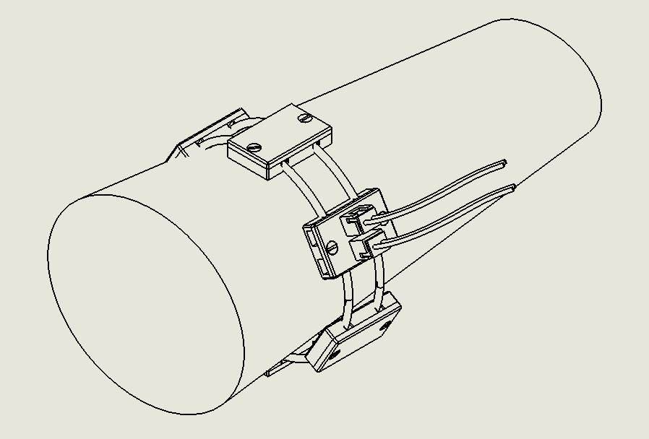

Figure 1 Band worn around the forearm

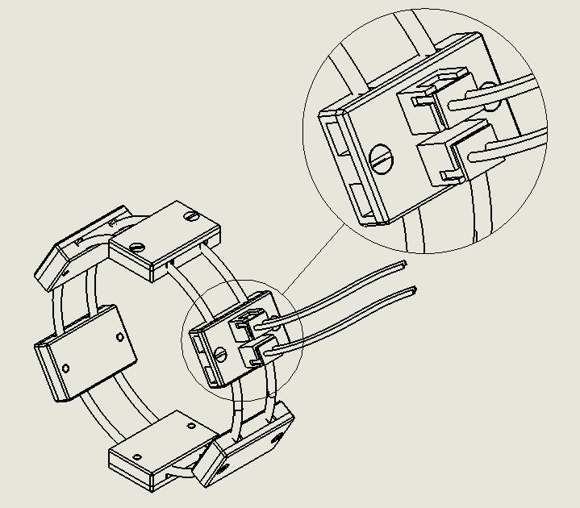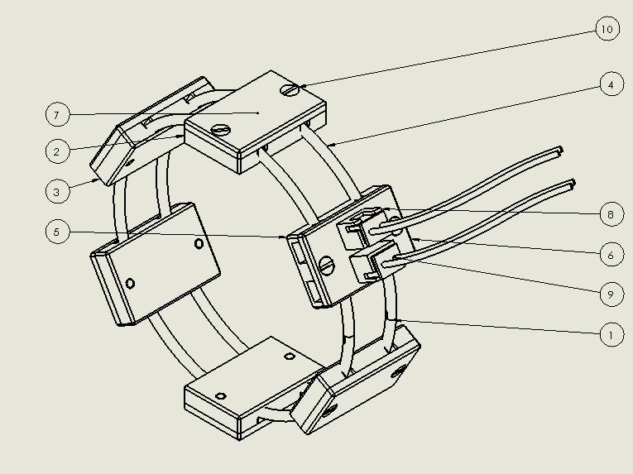

Figure 3. Detailed view of Pads with Connector plugs

Figure 2 Control band with detailed labelling

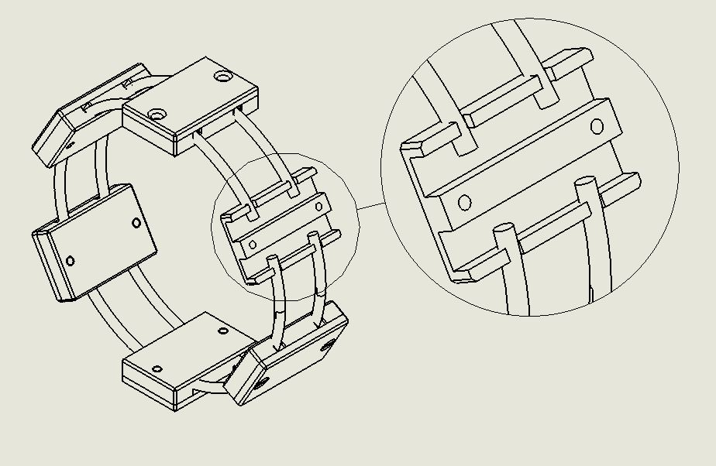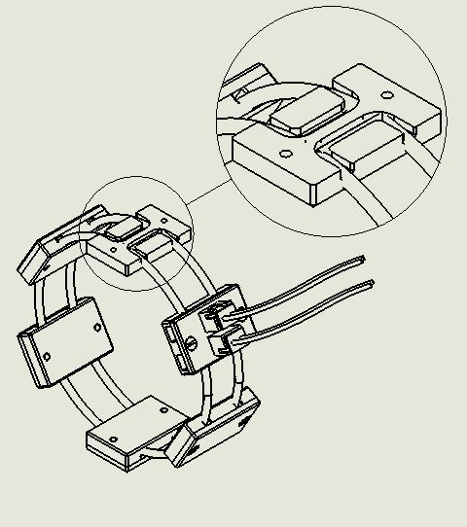

Figure 5 Closer view of pads at the crimped end of the Sensors

Figure 4. Pads with U looped sensors in place

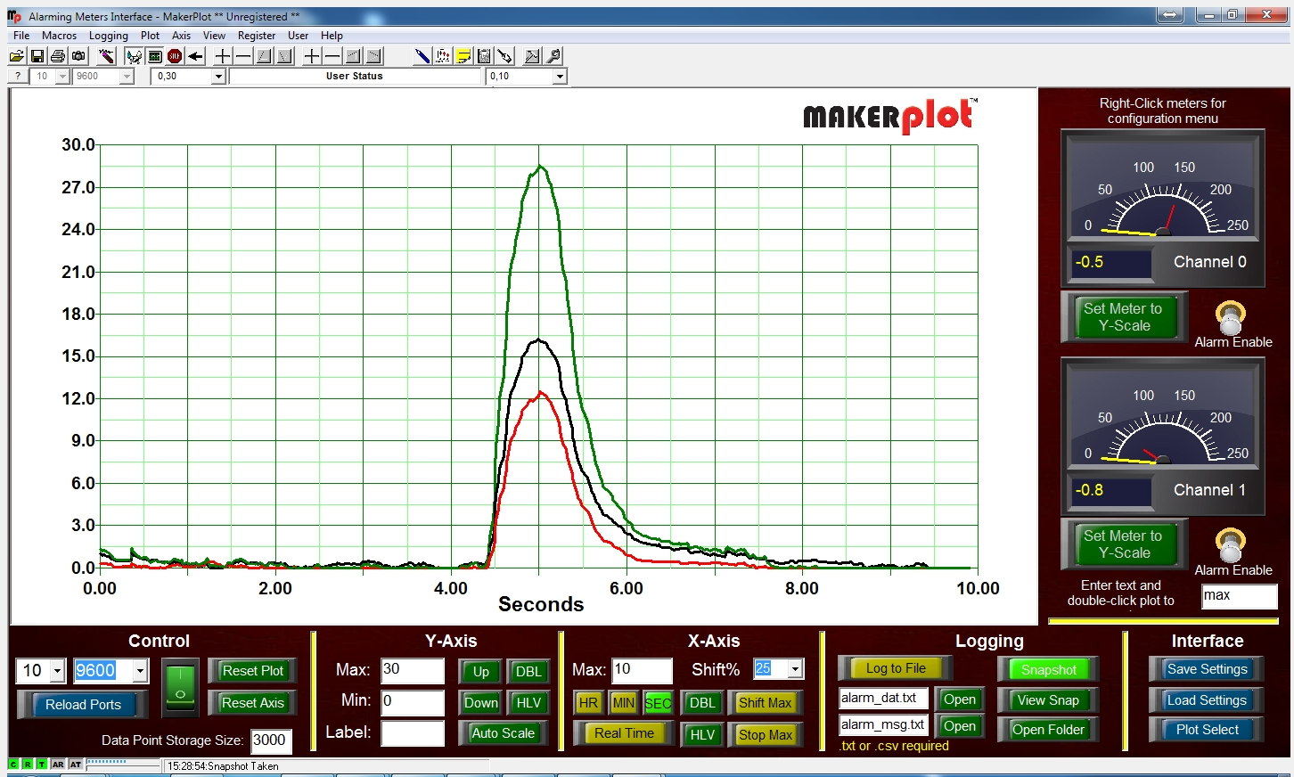

Figure 6. Plot of channel A and B and A+B

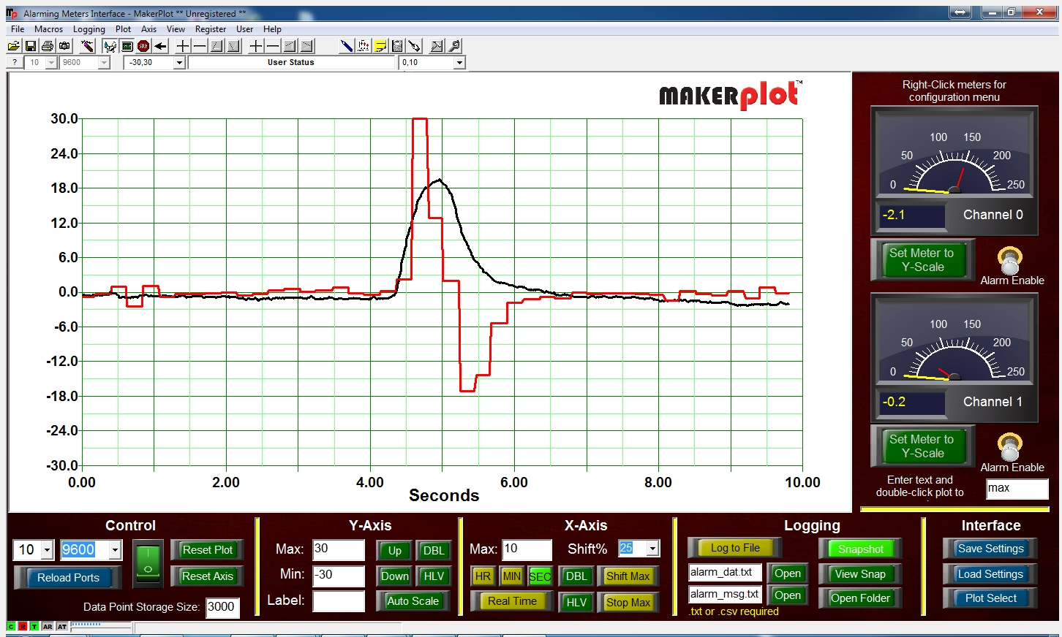

Figure 7. Derivative and Channel A+B

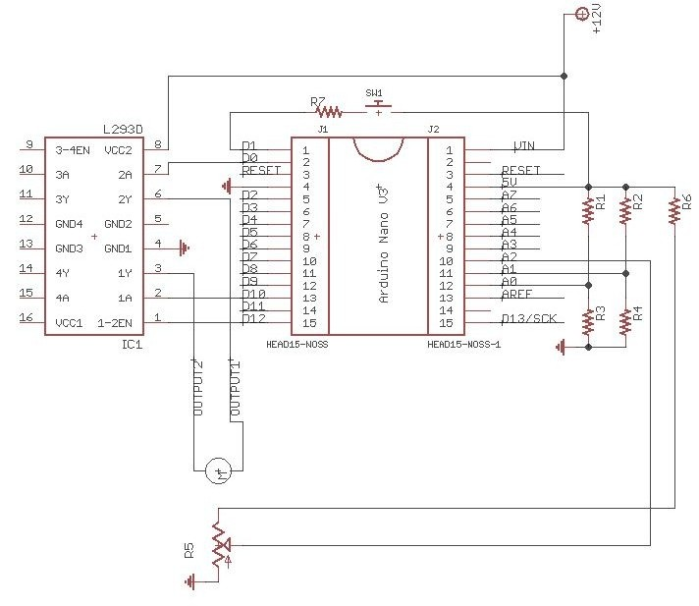

Figure 8. Circuit schematic

1. **Is there any other related disclosure(s) that you have already submitted at any forum or planning to submit in future? Kindly provide relevant details and list dates for such disclosures. The disclosure could be in any form including print and electronic media disclosure in a gathering of experts or in an exhibition.**
2. **What are the aspects of your disclosure that you want to claim/monopolize?**
3. Measurement of the circumference of any object.
4. Measure the squeeze in the fist both Kinetic and antagonistic.
5. Recognition of Pronation / supination, flexion and extension of the fingers and the wrist and the feet.
6. The variable change at the forearm is measured globally unlike any other existing device.
7. Design of the band with Pads to prevent the sensor digging into the skin.
8. Split of the sensors to gain measurement and reduce errors.
9. The use of the sensor property for both measurement and securely strapping to the forearm.
10. The algorithm such that the control of the devices is intuitive.
11. One button instant calibration and non-requirement of the specific orientation of the device on the arm.
12. Continuous data acquisition and real time mapping of the position of the fingers.
13. Specifically the use of this device in prosthesis both upper and lower.
14. The device could be used in the following areas:

Simple control of computers such as presentations, monitoring respiration of babies, measurement of expansion precisely , virtual reality such as picking things virtually, Using the device to accelerate a vehicle based on the squeeze a person applies on the handle, the band can be used as a replacement to already existent straps in the smart watches and increase the capability. Control of Robotic arms.

1. **Has your invention being reduced to practice? Has any prototype being made on this invention? If yes, kindly provide relevant information.**

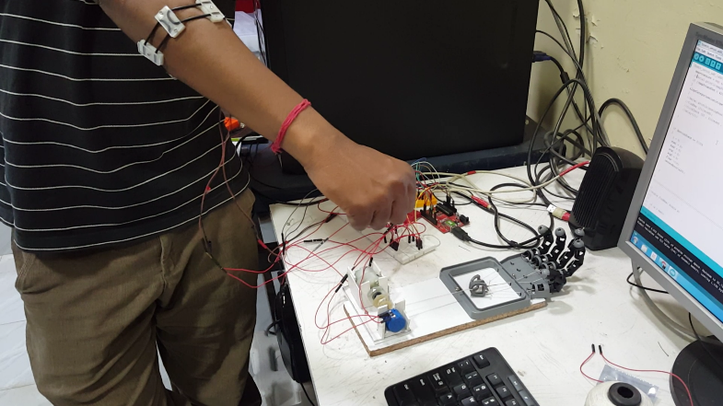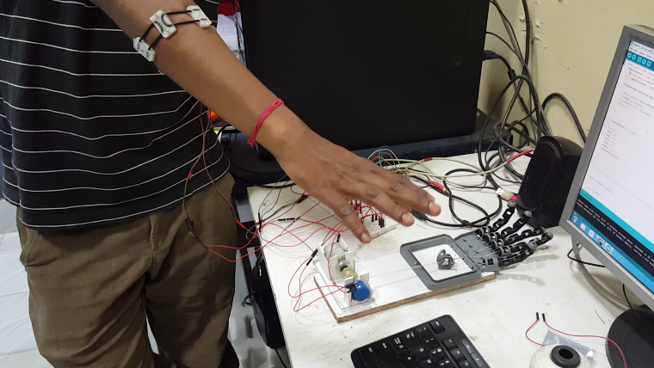A prototype has been built to control a simple one degree freedom prosthetic hand. The prosthetic hand itself is connected to rotary motor coupled with potentiometer to track the rotation of the motor. A string attached to the motor pulls the fingers in the prosthetic hand and the elastic nature of the fingers pulls back when left free. The rotary actuator is controlled through the signals from the band. The algorithm maps the number of rotations that the motor has to rotate based on the extent extension or flexion of the fingers in the wearer. Also the motor drives at a speed relevant to the rate of flexion or extension occurring.

1. **Software-related inventions should be supported with flow charts.**

Fingers in Flexion

Fingers not moving

Fingers in Extension

1. **Have you contacted any company/organization/agency to discuss commercialization of your invention? If yes, kindly give details.**
2. **Have you conducted novelty/inventiveness search for your invention? If yes, what are the databases /references used by you. What are the search results?**

US20120188158 A1

US20090327171 A1

US20140240223 A1

US20140249397 A1

US20130165813 A1

**Mechanomyography Sensor Development, Related Signal Processing, and Applications: A Systematic Review (**[IEEE Sensors Journa](http://ieeexplore.ieee.org/xpl/RecentIssue.jsp?punumber=7361)l 2013)

[**http://www.jeremyblum.com/portfolio/fsr-controlled-prosthetic-hand/**](http://www.jeremyblum.com/portfolio/fsr-controlled-prosthetic-hand/) **(open source)**

1. **Do you feel that a person of “average” skill (not-extraordinary skill) in your area of technology would have arrived at your invention with existing knowledge in public domain? If no, what could be the reasons for the same?**

No, as the information available in the open source and the patents filed till now as for my knowledge, have achieved gesture recognition through local measurements. However in this present invention the global measurement i.e the circumferential change in the forearm is recorded. Hence this is novel in the fundamental idea of dealing this problem.

1. **Kindly provide broad workable ranges for all the parameters involved in your invention.**

Voltage 5V

Current drawn: 10 mA

Dimensional change capable of measuring: Min 1 mm – Max 30mm

Weight:

1. **Department**

Center for Product Development and Manufacturing.

1. **Investigator/research scholar/degree student with email ID, Phone and fax Nos. of the principal investigator.**

**Student :**

Srinithish K

[nithish.kandagadla@gmail.com](mailto:nithish.kandagadla@gmail.com) , 9036655515

**Guide :**

Prof. Dibakar Sen.

1. **References** **(if any)**
2. **Who has funded the project/R&D Work and what are the funding conditions with specific reference to Intellectual Property Rights(IPR).**
3. **Any additional notes or remarks.**